Student Access Instructions for Ed (Math in Focus)

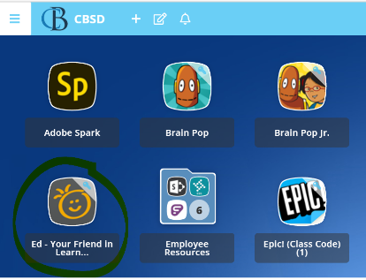

**From your child’s district device, go to ClassLink and find “Ed Your Friend” from the list of Apps.**

**Once you are in “Ed Your Friend” click the “Discover” tab at the top of the page.**



**Clicking on a chapter will take you to the online student workbook pages for that chapter.**

**Using the grey icons in “Ed Your Friend”, you can also find…**

* + Student Glossary with vocab definitions/pictures
  + Student Edition of the workbook
  + Graphical user interface, application

    Description automatically generatedGames – “Mini-Games”
  + Virtual Manipulatives